OOP Lab 12
12.1 Implement a GUI component scrollbar with the help of tkinter library.
Source code
from tkinter import *

Nabeel = Tk()
Nabeel.geometry("250x500+0+0")
Nabeel.title("Enter your age")
scrollbar = Scrollbar(Nabeel)
scrollbar.pack( side = RIGHT, fill = Y )

mylist = Listbox(Nabeel, yscrollcommand = scrollbar.set )
mylist.insert(END, "SELECT A NUMBER")
for line in range(100):
mylist.insert(END,str(line))

mylist.pack( side = LEFT, fill = BOTH )
scrollbar.config( command = mylist.yview )

mainloop()

Output
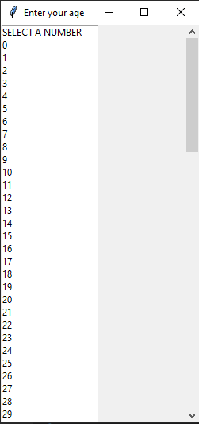

12.2 Implement a GUI component top level with the help of tkinter library.
Source code
from tkinter import *
nabeel = Tk()
nabeel.geometry("200x200")

def open():
top = Toplevel(nabeel)
top.mainloop()

btn = Button(nabeel, text="open", command=open)
btn.place(x=75, y=50)
nabeel.mainloop()

Output
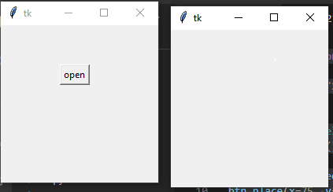

12.3 Implement a GUI component spin Box with the help of tkinter library.
Source code
from tkinter import *

Nabeel = Tk()
Nabeel.geometry("50x50+0+0")
w = Spinbox(Nabeel, from_=0, to=10)
w.pack()

mainloop()

Output
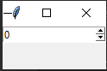

12.4 Implement a GUI component calendar with the help of tkinter library.
Source code
from tkinter import *
import calendar

def showCal() :

new_gui = Tk()
new_gui.config(background = "white")
new_gui.title("CALENDER")
new_gui.geometry("550x600")

fetch_year = int(year_field.get())
cal_content = calendar.calendar(fetch_year)
cal_year = Label(new_gui, text = cal_content, font = "Consolas 10 bold")
cal_year.grid(row = 5, column = 1, padx = 20)
new_gui.mainloop()

if __name__ == "__main__" :

gui = Tk()
gui.config(background = "white")
gui.title("CALENDER")
gui.geometry("250x140")
cal = Label(gui, text = "CALENDAR",
font = ("times", 28, 'bold'))

year = Label(gui, text = "Enter Year")
year_field = Entry(gui)

Show = Button(gui, text = "Show Calendar", fg = "Black",
command = showCal)

Exit = Button(gui, text = "Exit", command = exit)

cal.grid(row = 1, column = 1)
year.grid(row = 2, column = 1)
year_field.grid(row = 3, column = 1)
Show.grid(row = 4, column = 1)
Exit.grid(row = 6, column = 1)

gui.mainloop()

Output
